Together We Care. Together We Share.
Social Media Content

Below, please find suggested social media post copy to accompany the social media graphics that can be downloaded here. Upon campaign launch, we recommend adding NAMI.org/SupportGroups to Instagram bios for accessibility.

Social Media Post Copy | Social Graphic Visual
Are you experiencing stress, anxiety, depression or other mental health challenges? NAMI is here with free, peer-led groups in your community, available in-person or online — a safe space to share and get support. Join us.
Are you experiencing stress, anxiety, depression or other mental health challenges? NAMI is here with free, peer-led groups in your community, available in-person or online — a safe space to share and get support. Join us. | 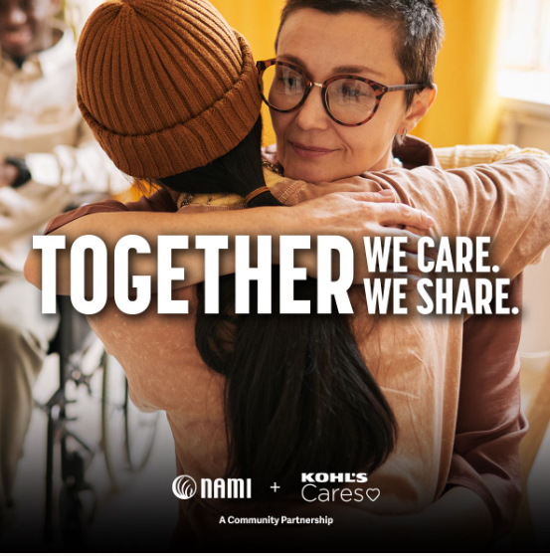
Few things are one-size-fits-all, including clothes and mental health. Kohl’s and NAMI are partnering to ensure every community has access to peer-led mental health support groups. More information at NAMI.org/SupportGroups. | 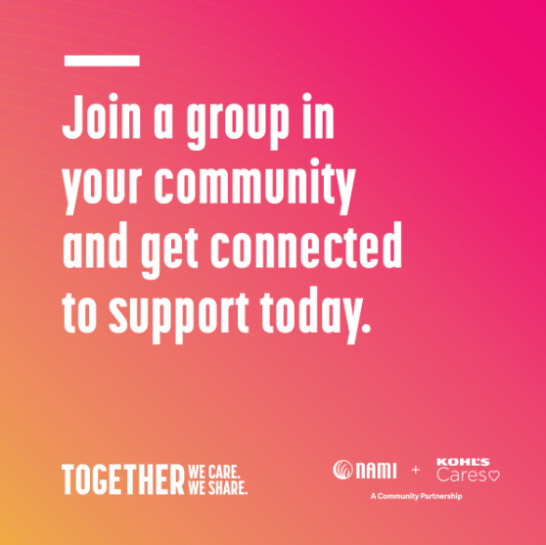
NAMI's peer-to-peer, community-based support groups connect individuals to share experiences and get support from people who understand. To join one near you, visit the link in bio. | 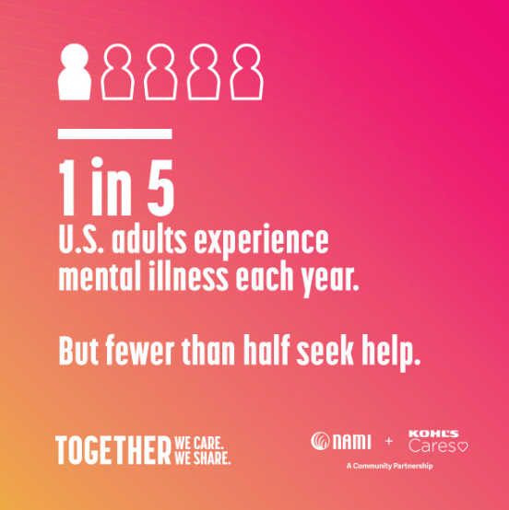
NAMI is here to help. Support groups create community, foster connection and lead to a sense of belonging. Learn more about NAMI and peer-led mental health support groups in your community and online at the link in bio. | [GIF]  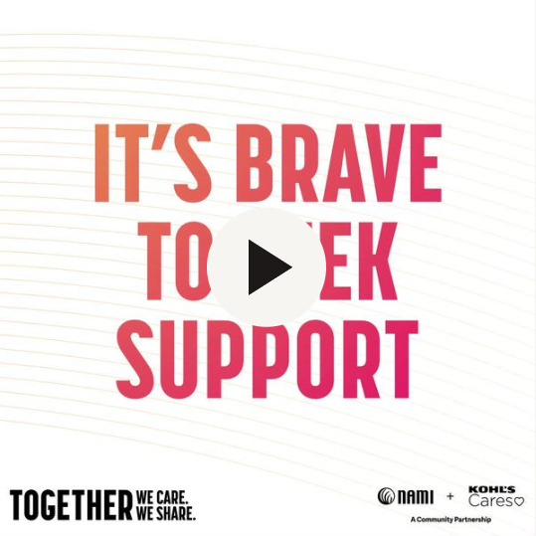

NAMI National Phase 2 Social Media Content

Below, please find suggested visuals (testimonial videos, social media graphics, a GIF and Instagram stories) alongside corresponding social media post copy as applicable. We recommend adding NAMI.org/SupportGroups to Instagram bios for accessibility and posting content at a cadence of 1 post per week depending on other content already scheduled.

The screen grabs for the videos below are square, but please note that they are formatted in three sizes: square (1 to 1), vertical (9x16) and horizontal (1.91x1). Select videos have Spanish captions as well, which are also noted below.

Video Post Copy | Video Visual (available in all platform sizes)
There is a community in NAMI. We’re here for you. Visit NAMI.org/SupportGroups to join a local NAMI Support Group in-person or online.

It’s normal to struggle with your mental health. But you don’t have to do it alone. Find your community at NAMI.org/SupportGroups. | 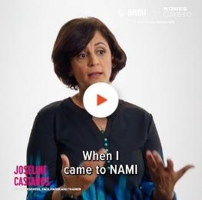
NAMI offers free support groups for individuals and families to authentically meet you where you are. Learn more at NAMI.org/SupportGroups.

Video Post Copy | Video Visual (available in all platform sizes)
NAMI Support Groups are here for you, no matter where you are in your mental health journey. Visit NAMI.org/SupportGroups to find your community.

Find a community focused on recovery by visiting NAMI.org/SupportGroups.

NAMI offers free support groups for individuals and families to authentically meet you where you are. Learn more at NAMI.org/SupportGroups.

NAMI Support Groups are here for you, no matter where you are in your mental health journey. Learn more at NAMI.org/SupportGroups. | 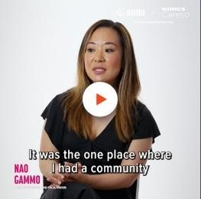

The visuals shown onbelow be found and downloaded from here.

Social Media Post Copy | Social Graphic Visual
NAMI Support Groups are here for you, no matter where you are in your mental health journey. Visit NAMI.org/SupportGroups to attend a peer-led group in your community for in-person or virtual support. | 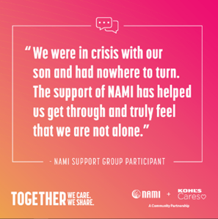
It’s normal to struggle with your mental health. But you don’t have to do it alone. Find your local community by visiting NAMI.org/SupportGroups. | 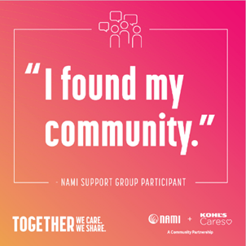
Always remember: mental health IS health. NAMI support groups are confidential, free and available near you in-person or online. Learn more by visiting NAMI.org/SupportGroups today. | 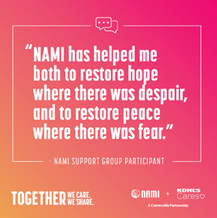
NAMI Support Groups are available nationwide. These groups are free, confidential and peer-led safe spaces for you to feel a sense of belonging. Visit NAMI.org/SupportGroups to learn more. | 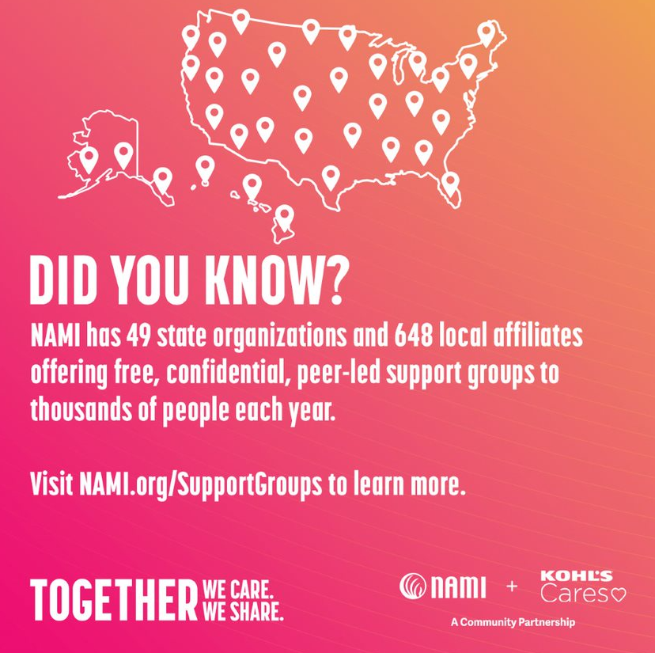
Social Media Post Copy | Social Graphic Visual
Visit NAMI.org/SupportGroups to find a support group near you. | [GIF]  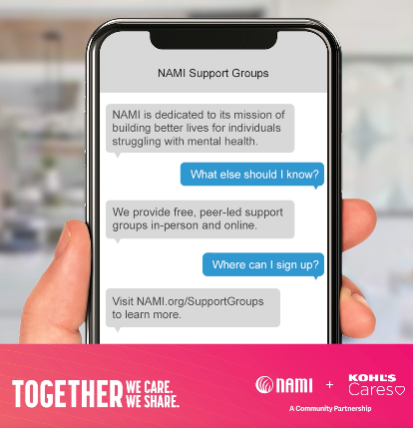
NAMI offers free support groups for individuals and families to authentically meet you where you are and be heard. Visit NAMI.org/SupportGroups to learn more. | 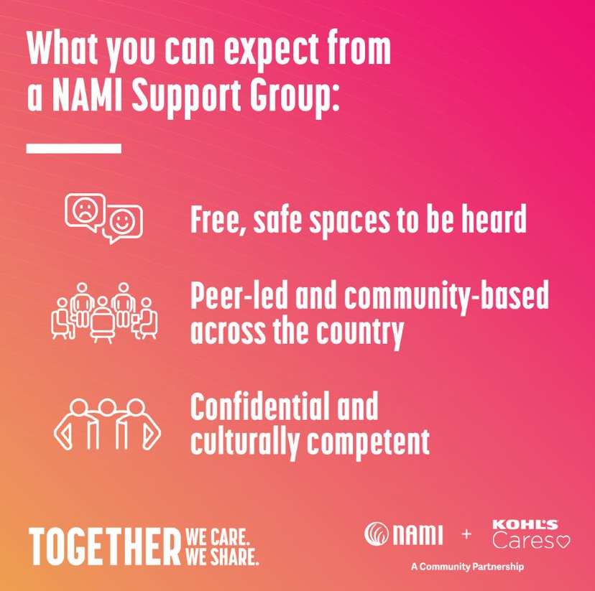
If you’re familiar with NAMI Support Groups, you know they couldn’t happen without the guidance of incredible peer facilitators. Your lived experience can help foster community and create a sense of belonging. Connect with your local NAMI to explore becoming a support group facilitator. | 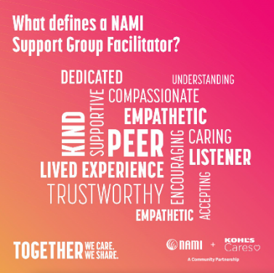

Instagram Stories
Instagram Story Posting Instructions
- Using sticker function, add link to NAMI.org/SupportGroups on final video frame

- We recommend creating an Instagram Support Group “highlight” and adding the Story to the highlight, so they live in posterity (and not just for 24 hours)

Did You Know? Instagram Story | Quotes Instagram Story
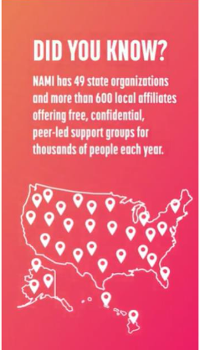  Note: the above is a screenshot of the first frame of the animation. | 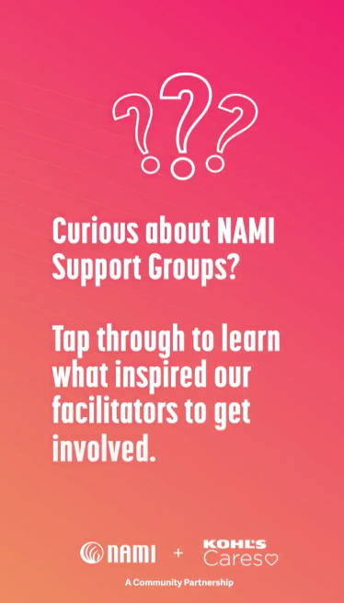  Note: the above is a screenshot of the first frame of the animation.

